**Main theme – Decision about the format of the Meetings**

**Let’s vote on these:**

1. **Scope of these Meetings – what do you want out of these meetings**
   1. Learning about the theory of ML and DL
   2. Learning about the applications of the ML in general
   3. Learning about the applications of the ML in Brain Imaging
   4. ML and DL? I thought this is more about data science
   5. Let’s skip the basics and just learn through the presented papers
2. **Meeting Style**
   1. **Free style:** the presenters are assigned for each day and the presenter will choose which topic or papers or paper to present
   2. **Fixed Topics:** If we have volunteers, they will present the selected topics and if not, we present an online lecture on that topic
   3. Paper presentation only?
   4. Lecture only?
   5. Combination of papers and lectures?
   6. Following a pre-existing curriculum from a pure ML, pure DL, or data science bootcamp
   7. Creating our own curriculum
   8. Workshop and hands on scripting on real data
3. **After we know the style, let’s brainstorm about the topics**
   * Provide Keywords:
     + bootstrapping,
     + permutation tests,
     + regularized regression
     + multi-voxel pattern analysis, graphical models
     + PCA
     + ICA
     + ...

An example curriculum would be: If we choose scope 3 (Learning about the applications of the ML in Brain Imaging), we can go over the topics in this example review paper I presented in a group meeting (Khosla, Sabuncu 2019) and assign people to present a paper/short lecture on these methods.

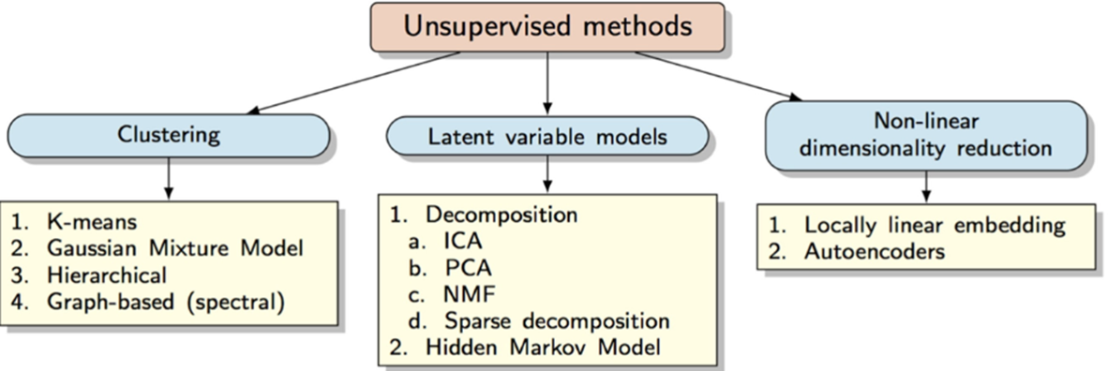

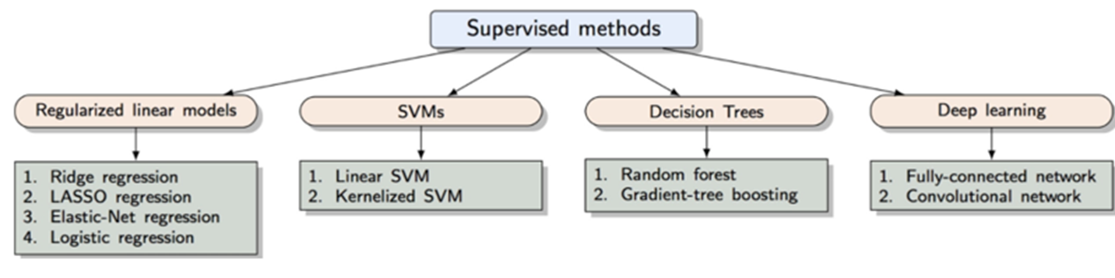

**Conclusion of the meeting:**

The majority of the people who attended our first meeting on Friday, voted on allocating our hour to learning a ML concept in the context of some hands on coding exercise (with or without relevance to brain signal processing).We decided to pick a long term goal based on the papers you guys are interested in, and set up a curriculum to get there. For this reason, please people will do a quick search by Wed. and post on slack some papers that they think they ultimately want to fully replicate, and I will try to come up with a curriculum.

We will discuss the curriculum this Friday. For the time-being, we also decided to kick off our ML coffee hour with a couple of sessions of basic statistics and python environment review sessions.